Maksims Kazijevs

COMP6200

04/18/2022

**Project 4**

**SOURCE CODE**

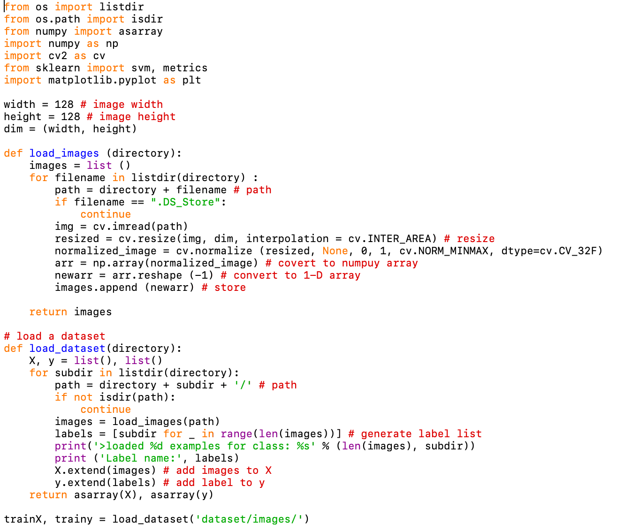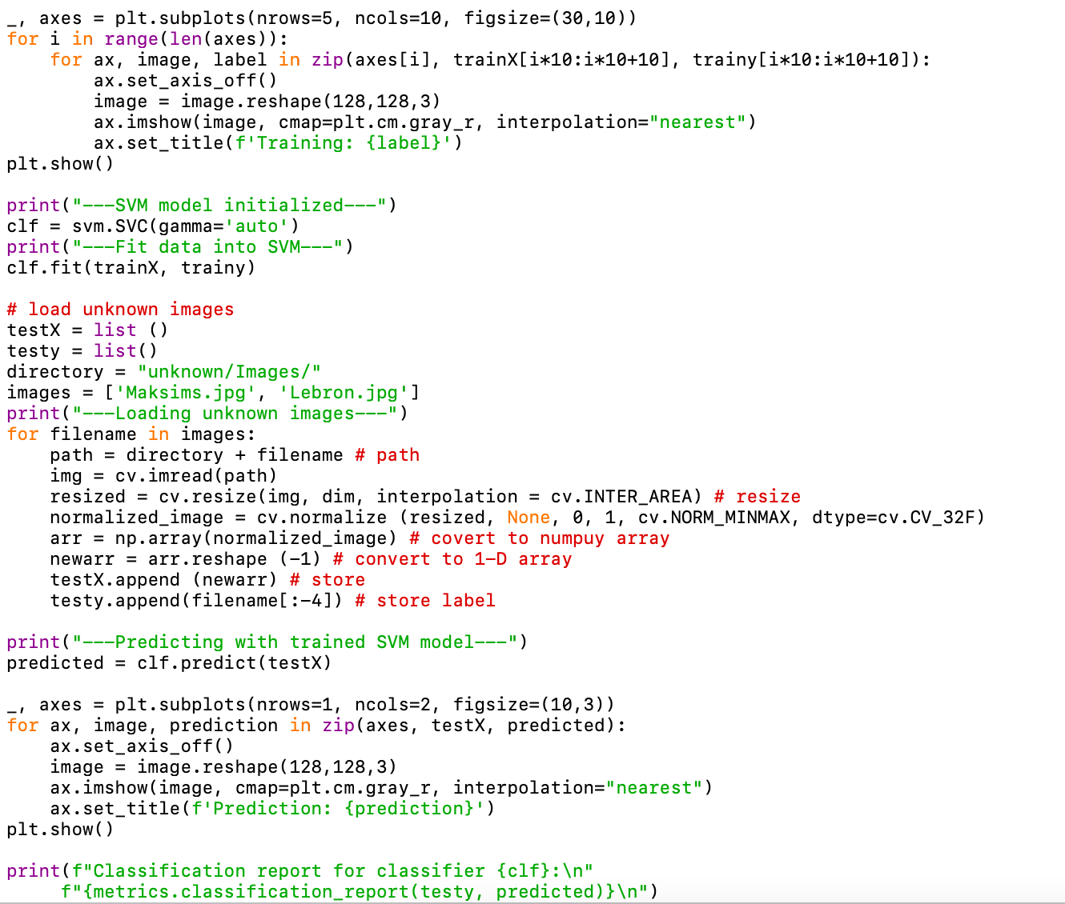

**RESULTS**

